So you wanna know how to make MSN Progs? Well if not then what the fuck are you doing reading this?
Anyways lets get down to business.

Contents
- Getting Started
- Changing Status
- Changing Username
- Getting Unread Email Count
- Reading Friends List
- Creating a Instant Message
- Quick Message

Getting Started

1st thing we do is set reference to the MSN Type Library. So create a new project then press ‘Alt + p’ then ‘Alt + n’.

Scroll down until you see MSN 1.0 Type Library.
Select it then press enter or click ok.

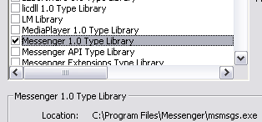

Now we need to assign a Name to the library.
So in the ‘General Declarations’ we type:
Public withevents MSN As MsgrObject

Public makes it available to the whole form.
Withevents allows us to capture events passed through the MSN library.
MSN is the name we are assigning it to
As MsgrObject is the class we are assigning it too

Now we have defined MSN we need to actually assign it to the library.

So now in the Form_Load sub we type:
Set MSN = New MsgrObject

You should now have this

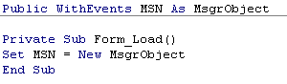

Congratulations you have taken the 1st step to joining the rest of the lamers

Logging On and Off

Ok here is to log on and off.

To log on we use the ‘Logon’ Function.

Sub Logon(bstrUser As String, bstrPassword As String, pService As IMsgrService)

Example:

To logoff is even simpler.

Just Type MSN.Logoff

Changing Status

To change Status is quite easy.

We change it by using the ‘LocalState’ Property.
This uses MSTATE which is a Enum
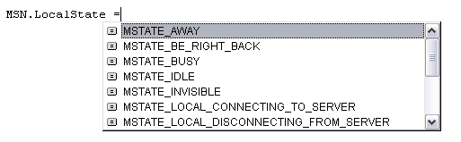
Here is a table that shows the values of each of the states

STATE | VALUE | Description
MSTATE_AWAY | 34 | The local or remote client user is away from the computer. This is a user-selected state.
MSTATE_BE_RIGHT_BACK | 14 | The local or remote client user is away from the computer for a short time. This is a user-selected state.
MSTATE_BUSY | 10 | The local or remote client is connected to a server and in a user-selected busy state.
MSTATE_IDLE | 18 | The local or remote client has not detected mouse or keyboard input on the computer for a determined time. The user is most likely away from the computer. The user can select whether to transmit idle state and idle time threshold.
MSTATE_INVISIBLE | 6 | The local or remote client is connected to a server, but invisible to other users.
MSTATE_LOCAL_CONNECTING_TO_SERVER | 512 | The local client is connecting to the server.
MSTATE_LOCAL_DISCONNECTING_FROM_SERVER | 1024 | The local client is disconnecting from the server.
MSTATE_FINDING_SERVER | 256 | The local client is attempting to find the server.
MSTATE_LOCAL_SYNCHRONIZING_WITH_SERVER | 768 | The local client is synchronizing with the server.
MSTATE_OFFLINE | 1 | The local or remote client is not connected to a server.
MSTATE_ON_THE_PHONE | 50 | The local or remote client user is on the phone. This is a user-selected state.
MSTATE_ONLINE | 2 | The local or remote client is connected to a server.
MSTATE_OUT_TO_LUNCH | 66 | The local or remote client user is at lunch. This is a user-selected state.
MSTATE_UNKNOWN | 0 | The state of the local or remote client is unknown.

So this means that you could put ‘MSN.LocalState = 10’ and it would be the same as ‘MSN.LocalState = MSTATE_BUSY’

*Hint: all the Enums used by MSN you can use too. Example: Dim Status As MSTATE

Change Username

This once again is very simple.
Property LocalFriendlyName As String

Example: MSN.LocalFriendlyName = “§e7eN Rulez!”

Get Unread Email Count

Property UnreadEmail(MFOLDER As MFOLDER) As Long

You have 2 folders:

-Inbox
-Others

This function uses another Enum called ‘MFOLDER’
It has the 2 folders

MFOLDER_ALL_OTHER_FOLDERS = 1
MFOLDER_INBOX = 0

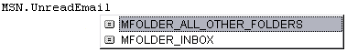
Lets say we want to return the amount of unread email in my inbox, we type:

Dim UnreadInboxCount As Long
UnreadInboxCount MSN.UnreadEmail(MFOLDER_INBOX)

Reading Friends List

Now it gets a little more complex.
There are 4 types if lists and they are also defined using an Enum.

Name | Value | Description
MLIST_ALLOW | 1 | Returns all the people who are on your list and is allowed to view your status.
MLIST_BLOCK | 2 | Returns all the people who you have blocked.
MLIST_CONTACT | 0 | Returns all the people you have added.
MLIST_REVERSE | 3 | Returns all the people who have added you.

Ok, lets say we want to return all the people we have added and put it into a list box.

Ok MSN.List(MLIST_CONTACT)(X) will return all the info about the user (X being the Index)

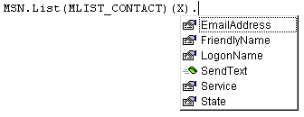
Ok the whole thing together is:

Dim X As Integer

For X = 0 To MSN.List(MLIST_CONTACT).Count –1

List1.Additem MSN.List(MLIST_CONTACT)(X).FriendlyName

Next

That’s it you have just loaded everyone into a list box.

Creating a Instant Message

Like the ‘MSN library’ we assigned to MSN we will need to assign the user to a Value.
We do this by:

In the general Declarations type:

Dim pUser As IMsgrUser
Dim IMSession As IMsgrIMSession

I will just create some subs because it’s the quickest and neatest way.

Sub SendMessege(IMSession As IMsgrIMSession, Message As String)
IMSession.SendText "", Message, MMSGTYPE_NO_RESULT
End Sub

Function CreateIM(Email As String) As IMsgrIMSession
Set pUser = MSN.CreateUser(Email, MSN.Services.PrimaryService)
Set pUser = Nothing
Set CreateIM = MSN.CreateIMSession(pUser)
End Function

Sub AddUser(IMSession As IMsgrIMSession, Email As String)
Set pUser = MSN.CreateUser(Email, MSN.Services.PrimaryService)
IMSession.InviteUser pUser
Set pUser = Nothing
End Sub

Great, you have got the subs now how the hell do you use them?
Ill tell you.

We 1st create the IM session using the CreateIM sub
Example: Set IMSession = CreateIM(“Hate_114@hotmail.com”)

Then to send a message we use the SendMessege sub
Example: SendMessege(IMSession, “Hey There!”)

Then to invite someone we use the AddUser sub
Example: AddUser(IMSession, “Hate_114@hotmail.com”)

Quick Send Message

An Alternate way to creating a IM

Sub QuickMessage(Email as String, Message as String)
Set pUser = MSN.CreateUser(Email, MSN.Services.PrimaryService)
pUser.SendText "", Message, MMSGTYPE_NO_RESULT
Set pUser = Nothing
End sub

Conclusion:

Please Vote and leave comments. This is my 1st tutorial so go easy on me, im not good at explaining things.
Depending what kind of response I get will determine whether or not I write one for Messenger API.
I Hope This tutorial has helped you in some way.

Click here for all my other codes

